

**KOI VETERINARY SERVICE CENTER**

**Software Requirement Document**

**Report 2 - Overall Description**

– HoChiMinh, August 2022 –

**Table of Contents**

Record of Changes 3

II. Overall Description 4

1. Product Overview 4

2. Business Process 5

# Record of Changes

| **Date** | **A* M, D** | **In charge** | **Change Description** |
| --- | --- | --- | --- |
|  |  |  |  |
|  |  |  |  |
|  |  |  |  |
|  |  |  |  |
|  |  |  |  |
|  |  |  |  |
|  |  |  |  |
|  |  |  |  |
|  |  |  |  |
|  |  |  |  |
|  |  |  |  |
|  |  |  |  |
|  |  |  |  |

*A - Added M - Modified D - Deleted

# II. Overall Description

## 1. Product Overview

The Koi Fish Veterinary Appointment Management System is designed to provide an easy-to-use platform for booking and managing veterinary consultations, with a specific focus on Koi fish health services. Given the rising popularity of keeping Koi fish, proper health management and maintenance of these ponds is becoming an increasing concern for owners. The system is aimed at assisting Koi fish owners in booking health consultations for their fish, whether remotely or in-person, to ensure the highest quality care

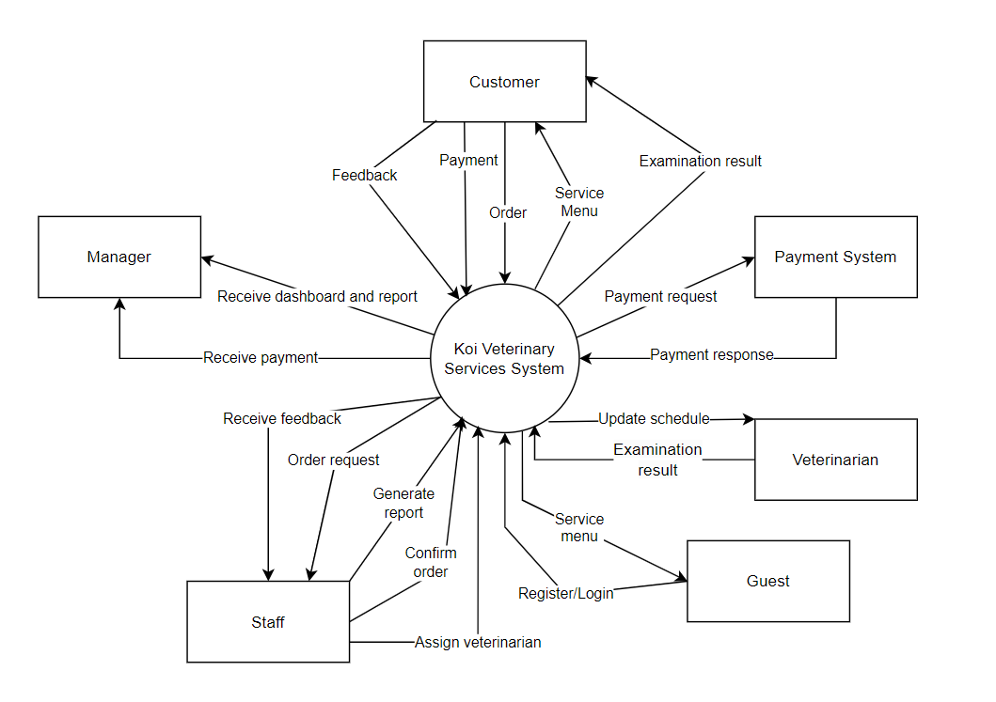

## 2. Business Process

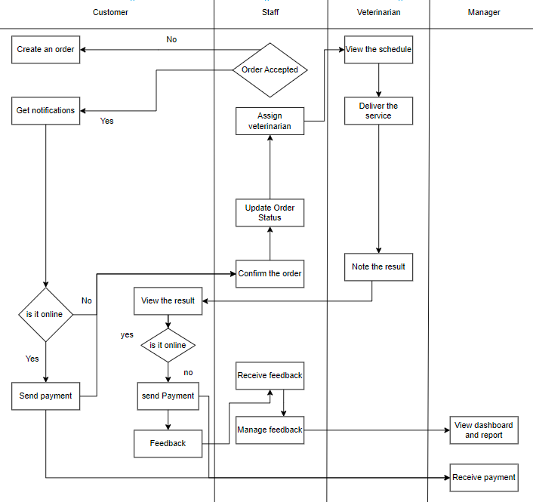

| **#** | **Process Step** | **Description** |
| --- | --- | --- |
| 1 | Create an order | Fill in information to create a new order/appointment . |
| 2 | Order accepted | If the customer does not confirm the appointment, cancel the appointment registration. And if the customer confirms the appointment, continue to the next step. |
| 3 | Get invoice | Get the invoice information of the system and show it to the customer |
| 4 | Send payment | The customer proceeds to pay the down payment to continue with the appointment. |
| 5 | Receive payment | The manager will receive the payment from the customer. |
| 6 | Update order status | Update the order status in the system and forward the order to staff. |
| 7 | Confirm the order | Staff receive the information of the order and confirm the order if the order information is correct and feasible or not. |
| 8 | Assign veterinarian | Staff assign the veterinarian if the customer did not choose the veterinarian first. |
| 9 | View the schedule | The order information reflects into the specific veterinarian’s schedule and that veterinarian is only able to view his/her own schedule. |
| 10 | Deliver the service | The veterinarian delivers the service based on his/her schedule. |
| 11 | Note the result | The veterinarian notes the result of his/her examination and the advice the customer should follow |
| 12 | View the result | The customer sees the result of the particular appointment they’ve ordered after that appointment is done. |
| 13 | Feedback | The customer writes the feedback of a particular appointment they’ve ordered. |
| 14 | Receive feedback | The staff receives the feedback from the customer and manages it depending on circumstances. |
| 15 | View dashboard and report | The manager will receive the report of the revenue, overall feedback of the customer, what services did the customer book the most and which veterinarian did the customer choose the most. |